Chapter 5 PROBLEM SET
Open up the CHAPTER 5 POWERPOINT LECTURE posted in the class on D2L. Click the VIEW tab and go to page 45. Change the View to “Notes Page”.
The problems are given in the Notes Page view, on slides 45 to 47. Save the queries as ch5p1 through ch5p6. (Note that the results shown in the figures include a row number, but your solutions will not. )
Include the following comments at the top:
-- Your Name
-- Date
Put all of the queries in one script, and do not zip the file.
Ch5p7: Write a query to display ‘Small’, ‘Medium’, ‘Large’ for a classroom, based on the capacity of the room. If the capacity is >= 100, then it is ‘Large’, between 30 and 99 is ‘Medium’, and less than 30 is ‘Small’. Use the Location table and a Case statement to complete this query. Here are the results (note column headings):
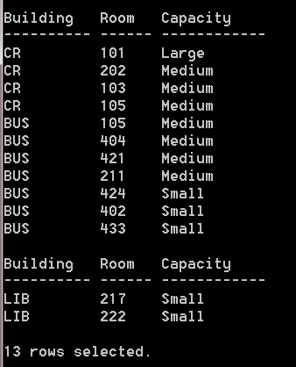
Ch5p8: Write a query that displays the call id, course name, and level of the course, based on the course number as shown below:
If the number starts with a
“1” -- Freshman
“2” -- Sophomore
“3” -- Junior
“4” -- Senior.
Anything else should display “Invalid Level”.
Label the grade column Level. Order by Level, then call ID. Here is the result of the query:
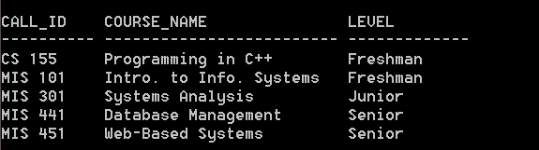

Ch5p9: Using the Animal Shelter schema, create a new problem using the features introduced in this chapter.

